Lab Assignment 5
Name: Atharvanath Jha
Roll no. 38

Question1: Write a C program to reverse an integer/float array.
#include<stdio.h>
int main(){
int n;
int i;

printf("\nWhat lenght array do you want? ");
scanf("%d", &n);

int arr[n];

for(i = 0; i < n; i++){
printf("\n %d th element: ", i);
scanf("%d", &arr[i]);
}

printf("\n The original array is: ");
for(i = 0; i < n; i++){
printf("%d \n", arr[i]);
}

for(i = 0; i < n/2; i++){
int temp = arr[i];
arr[i] = arr[n - 1 - i];
arr[n - 1 - i] = temp;
}

printf("\n The original array is:\n ");
for(i = 0; i < n; i++){
printf("%d \n", arr[i]);
}

}
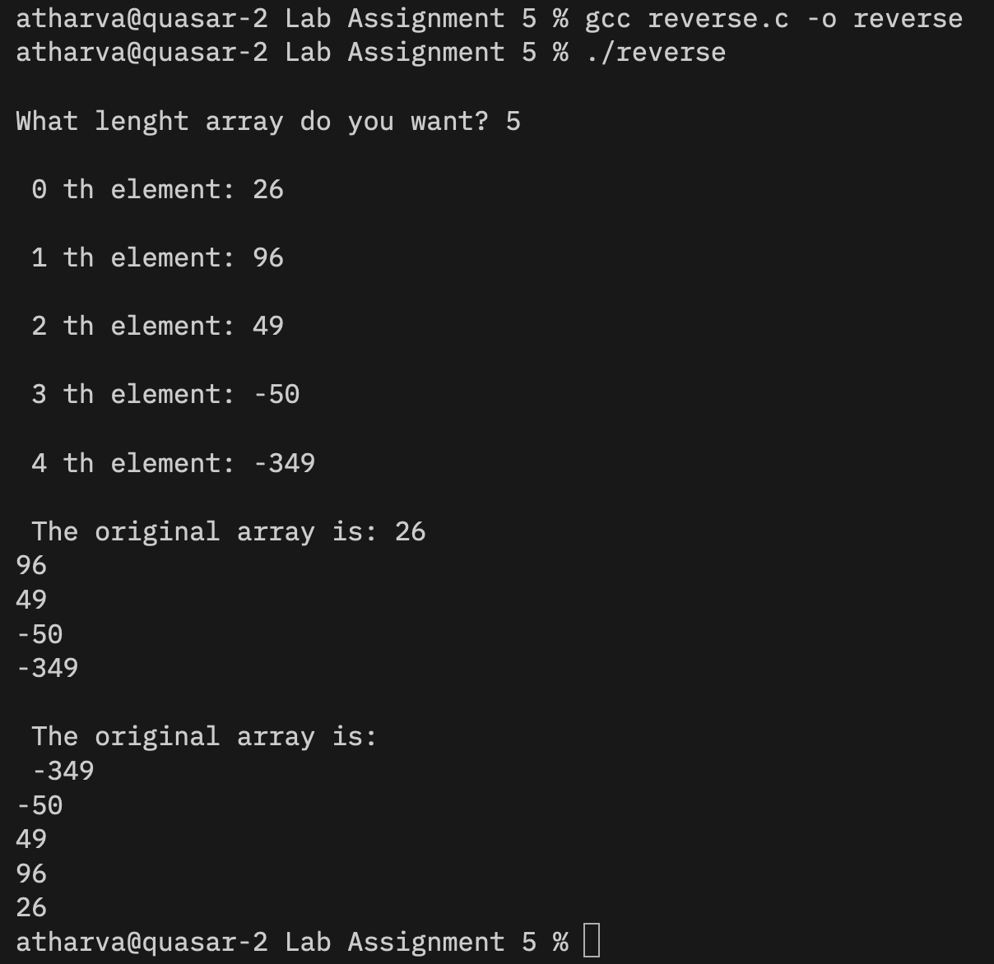

Question2: To insert an element at a given location of an array.
#include<stdio.h>
int main(){
int n;
int i;
int index;
int val;

printf("\nEnter size of array: ");
scanf("%d", &n);

int arr[n+1];

printf("\nEnter the elements: ");
for ( i = 0; i < n; i++){
scanf("%d", &arr[i]);
}

printf("\nOriginal Array: ");
for( i = 0; i < n; i++){
printf("%d ", arr[i]);
}

printf("\n");

printf("At which index do you want the new value? ->");
scanf("%d", &index);

printf("\nEnter new element: ");
scanf("%d", &val);

for ( i = n; i > index; i--){
arr[i] = arr[i-1];
}
arr[index] = val;
n++;

printf("\nUpdate Array\n");
for(i = 0; i < n; i++){
printf("%d ", arr[i]);
}
}
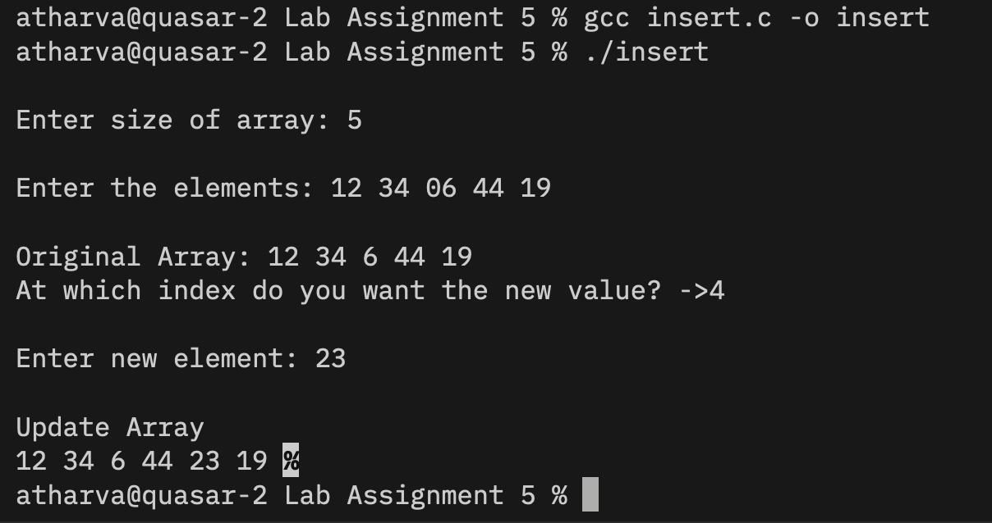

Question3: Delete a given element in an array.
//Doubt - desired output is not coming!!
// reused the code written for insertion as deletionn is opposite of insertion

#include<stdio.h>
int main(){
int n;
int i;
int index;
// int val;

printf("\nEnter size of array: ");
scanf("%d", &n);

int arr[n];

printf("\nEnter the elements: ");
for ( i = 0; i < n; i++){
scanf("%d", &arr[i]);
}

printf("\nOriginal Array: ");
for( i = 0; i < n; i++){
printf("%d ", arr[i]);
}
printf("\n");

printf("From which index do you want to delete? ->");
scanf("%d", &index);

// printf("\nEnter new element: ");
// scanf("%d", &val);

for ( i = index; i > n - 1; i++){
arr[i] = arr[i+1];
}

// arr[index] = val;
n--;

printf("\nUpdate Array\n");
for(i = 0; i < n; i++){
printf("%d ", arr[i]);
}

}

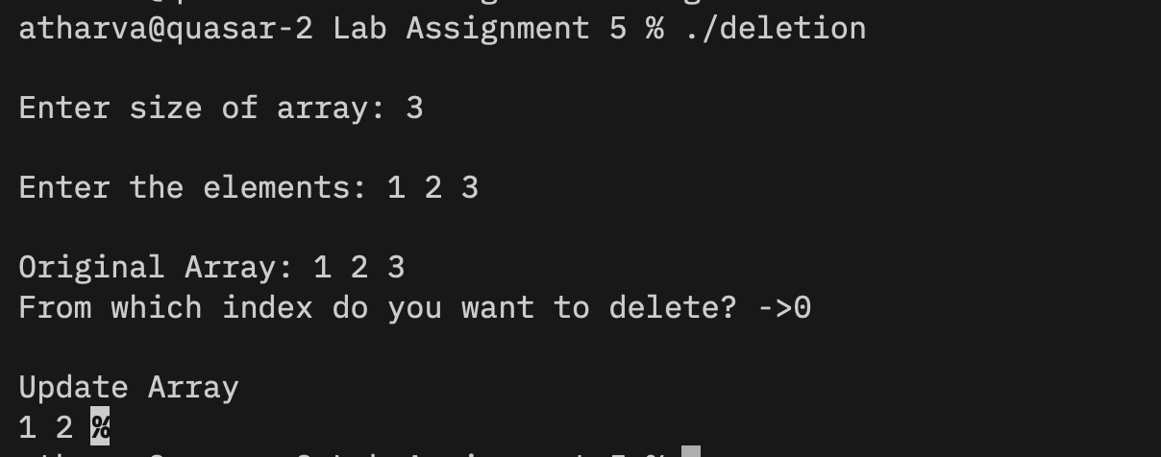

Question4: Linear Search.
#include<stdio.h>
int main(){
int n;
int val;

printf("\nLength of array: ");
scanf("%d", &n);

int arr[n];
printf("\nEnter the elements of the array: ");
for( int i = 0; i < n; i++){
scanf("%d", &arr[i]);
}

printf("\nSearch item: ");
scanf("%d", &val);

for(int i = 0; i < n; i++){
if (arr[i] == val){
printf("%d was found at %d th index.", val, i);
}
}
printf("\n");
}
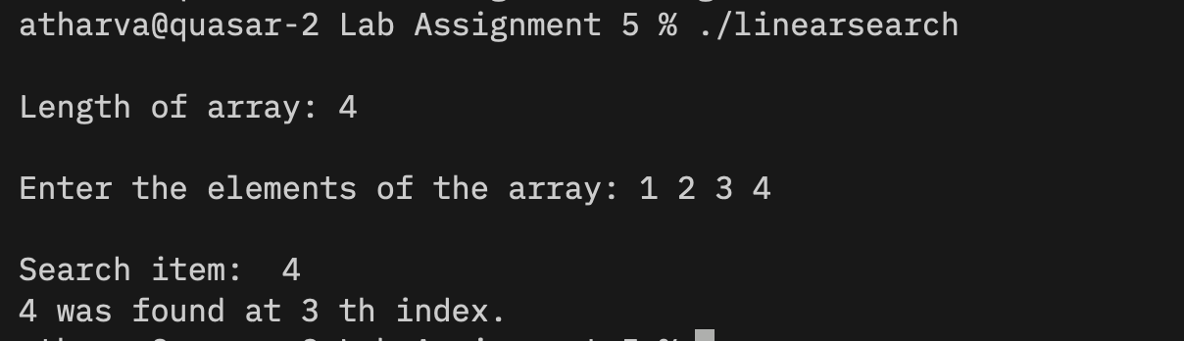

Question 5: Binary Search
#include<stdio.h>
int main(){
int n, i, j;
int temp;

printf("\nEnter length of array: ");
scanf("%d", &n);

int arr[n];

printf("\nEnter the elements: ");
for( i = 0; i < n; i ++){
scanf("%d", &arr[i]);
}

printf("\nInitial Array\n");
for( i = 0; i < n; i++){
printf("%d, ", arr[i]);
}

for ( i = 0; i < n - 1; i++){
for ( j = 0; j < n - 1 - i; j++){
if (arr[j] > arr[j+1]){
temp = arr[j];
arr[j] = arr[j + 1];
arr[j + 1] = temp;
}
}
}

printf("\nSorted Array\n");
for( i = 0; i < n; i++){
printf("%d, ", arr[i]);
}
}

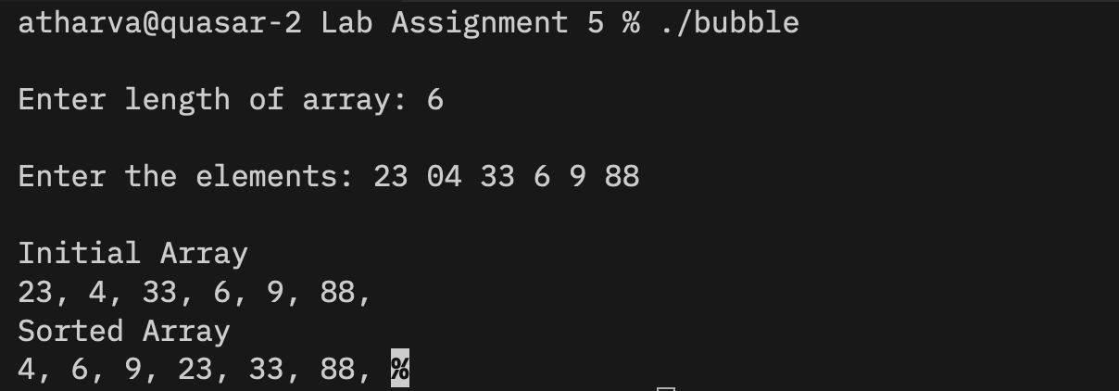

Question 6: Sum and average of array elements.
#include<stdio.h>
int main(){
int n, i;
int sum;
float avg;

printf("\nEnter array length: ");
scanf("%d", &n);

int arr[n];

printf("\nEnter array elements: ");
for( i =0; i < n; i++){
scanf("%d", &arr[i]);
}

printf("\nOriginal Array\n");
for( i =0; i < n; i++){
printf("%d, ", arr[i]);
}

for( i = 0; i < n; i++){
sum += arr[i];
}
printf("\nSum = %d", sum-1);

avg = sum / n;
printf("\nAverage = %f \n", avg);
}
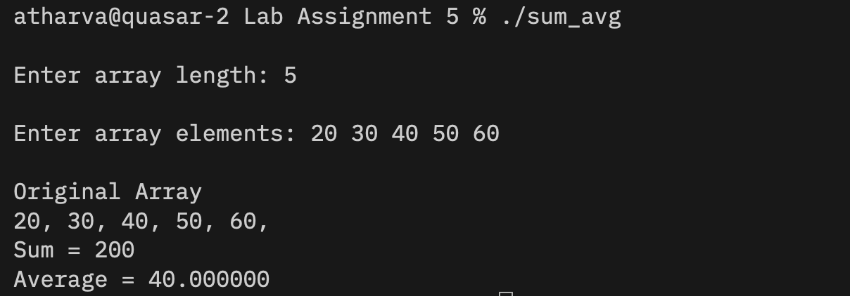

NOTE: Due to repetitive code for taking array length n as user input and then initializing an integer array of that length and then taking user input for all the elements of the array, I have created a header file to avoid the reptition.
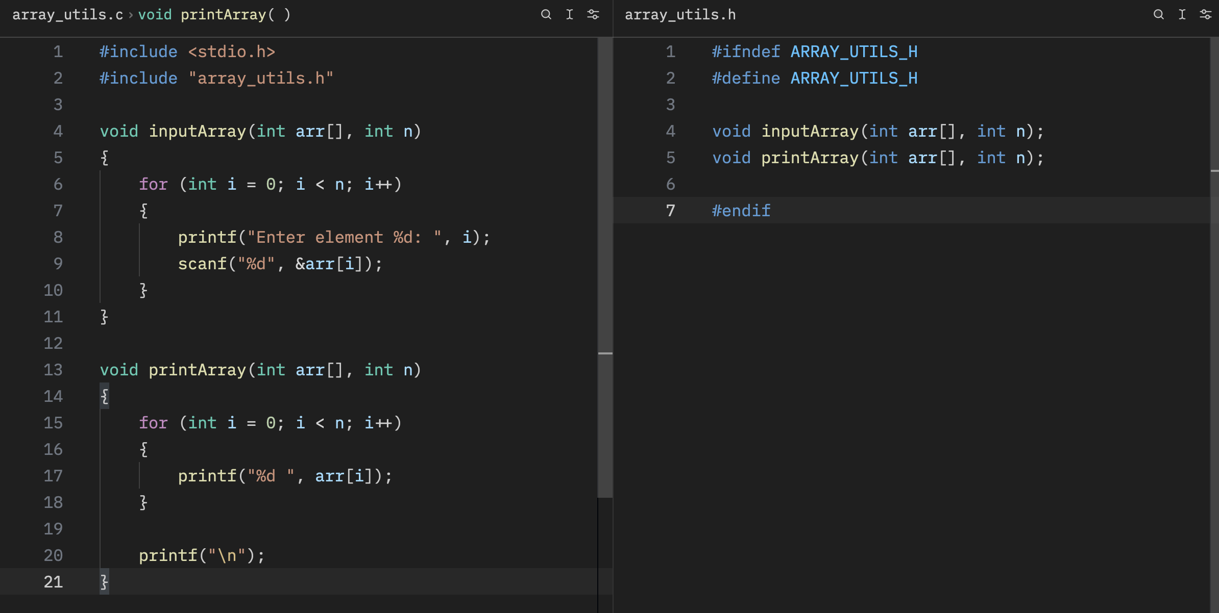

Question7: Merge two arrays.
#include<stdio.h>
#include "array_utils.h"

int main(){
int i, len1, len2;

printf("\nEnter size of 1st array: ");
scanf("%d", &len1);

int arr_1[len1];

printf("\nEnter size of 2nd array: ");
scanf("%d", &len2);

int arr_2[len2];

printf("\nEnter elements in 1st array: ");
inputArray(arr_1, len1);
printf("\nEnter elements in 2nd array: ");
inputArray(arr_2, len2);

printf("\nArray 1: ");
printArray(arr_1, len1);
printf("\nArray 2: ");
printArray(arr_2, len2);

int arr_merged[len1 + len2];

for(i = 0; i < len1; i++){
arr_merged[i] = arr_1[i];
}
for(i = 0; i < len2; i++){
arr_merged[len1 + i] = arr_2[i];
}

printf("\nMerged Array: ");
printArray(arr_merged, len1 + len2);

}
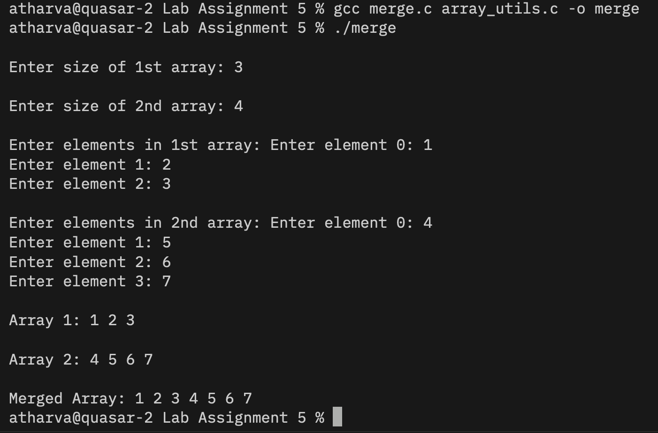

Question 8: Find the largest and smallest element in an array.
#include<stdio.h>
#include "array_utils.h"
int main(){
int n, i, j;

printf("\nArray length: ");
scanf("%d", &n);

int arr[n];

printf("enter the array elements: \n");
inputArray(arr, n);

printf("\nyour array: ");
printArray(arr, n);

//if we sort the array then the 0th element will by default
// be the smallest and the n-1 th element will be largest.

int temp;

for(i = 0; i < n - 1; i++){
for(j = 0; j < n - 1 - i; j++){
if(arr[j] > arr[j + 1]){
temp = arr[j];
arr[j] = arr[j + 1];
arr[j + 1] = temp;
}
}
}

printf("\nsorted array -> ");
printArray(arr, n);

int min = arr[0];
int max = arr[n-1];

printf("\n%d is the smallest and %d is the largest.\n", min, max);

}
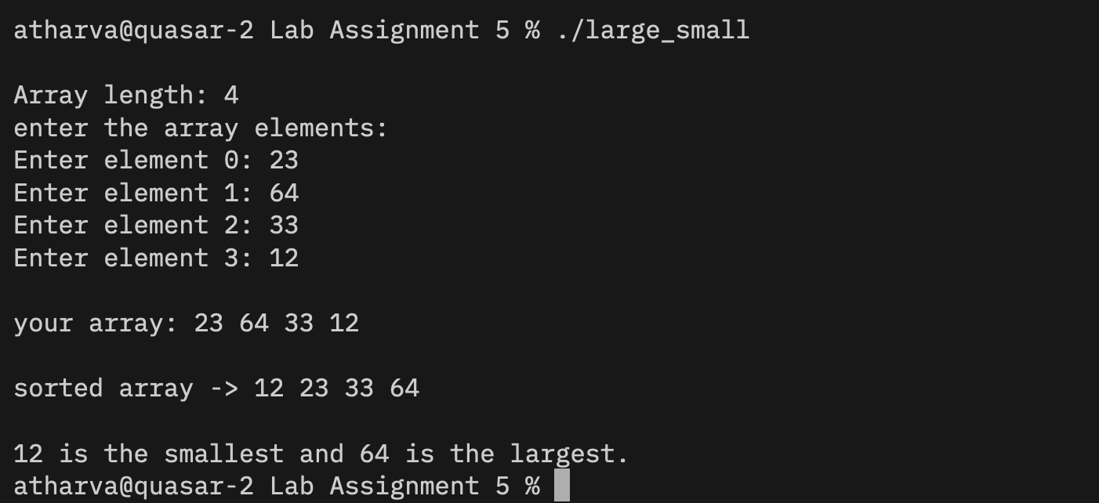

Question 9: Take the union and intersection of two arrays.
#include<stdio.h>
#include "array_utils.h"
int main(){
int i, j, n1, n2;
int check;

printf("\n1st Array lenght: ");
scanf("%d", &n1);
int arr_1[n1];

printf("\nEnter elements: ");
inputArray(arr_1, n1);

printf("\n2nd Array lenght: ");
scanf("%d", &n2);
int arr_2[n2];

printf("\nEnter elements: ");
inputArray(arr_2, n2);

printf("\ninitial arrays are: \n");
printArray(arr_1, n1);
printf("\n");
printArray(arr_2, n2);

int merge[n1 + n2];

for(i = 0; i < n1; i++){
merge[i] = arr_1[i];
}
for(i = 0; i < n2; i++){
merge[n1 + i] = arr_2[i];
}

printf("\nUnion : ");
printArray(merge, n1+n2);

int inter[n1 > n2 ? n1 : n2];
int k = 0;

for(i = 0; i < n1; i ++){
check = 0;

for(j = 0; j < n2; j++){
if(arr_1[i] == arr_2[j]){
check = 1;
break;
}
}

if(check){
inter[k] = arr_1[i];
k++;
}
}

printf("\nintersection : ");
printArray(inter, k);
}
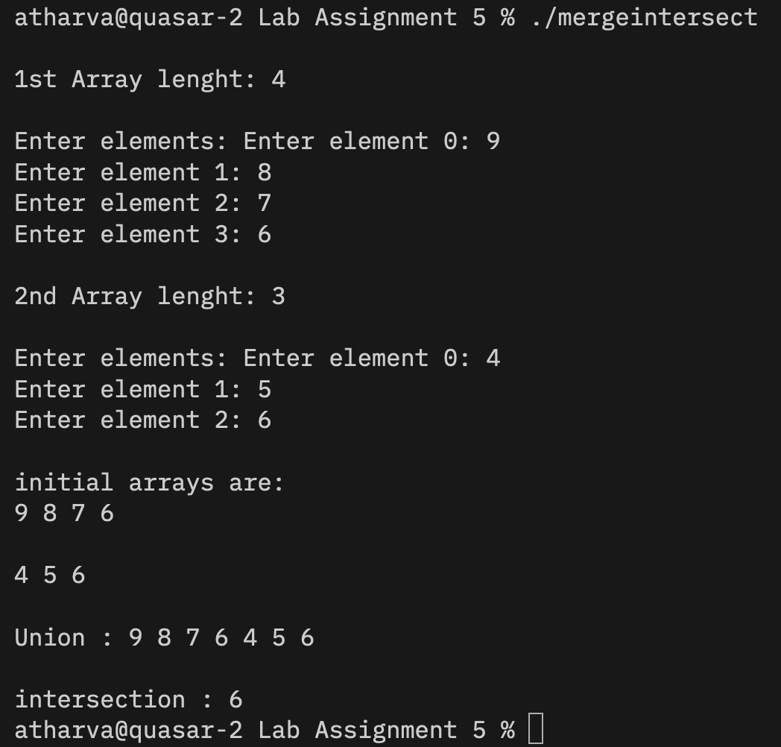

Question 10: Remove duplicates in an array.
#include<stdio.h>
int main(){
int n, i, j, k;

printf("\nArray length: ");
scanf("%d", &n);

int arr[n];

printf("\nEnter the elements: ");
for (i = 0; i < n; i++){
scanf("%d", &arr[i]);
}

printf("\nThe original array: ");
for (i = 0; i < n; i++){
printf("%d ", arr[i]);
}

for( i = 0; i < n; i++){
for ( j = i + 1; j < n; j++){
if(arr[i] == arr[j]){
for ( k = j; k < n - 1; k++){
arr[k] = arr[k + 1];
}

n--;
j--;
}
}
}

printf("\nFinal array: ");
for(i = 0; i < n; i++){
printf("%d ", arr[i]);
}
}
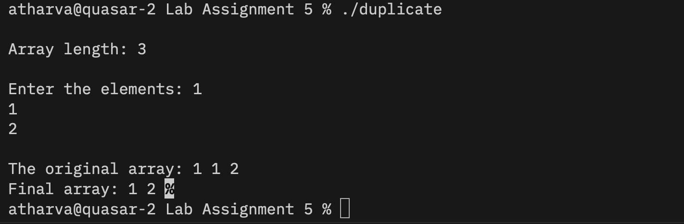

Question 11:

